

Internship Report

On



“Daraz Bangladesh Limited – A New Era of Bangladesh E-commerce.

– Change your shopping Style.”

Supervised By:
Md. Tamzidul Islam
Assistant Professor
BRAC Business School,
BRAC University,Bangladesh

Submitted By:
Nur Ibna Saeed
ID-09104133
BRAC Business School

Date of Submission
31 Aug 2016

Letter of Transmittal

Dear Sir,

Subject: Submission of Internship report.

I would like to submit my report titled “Daraz Bangladesh Limited a New Era of Bangladesh E-commerce – changed your shopping style.” prepared as a part of the requirement for BBA program of BRAC Business School.

I have worked in Daraz Bangladesh Limited from the very beginning as a founding employee. Working in this report is a great learning and opportunity to share my experience as I have implemented my theoretical knowledge in practical work life. I hope you will find this report systematic and a reliable source of data.
.

I would like to take this opportunity to thank you for all the support and guidelines that you have provided, which I hope to continue getting in the future. Meanwhile, I will be available if you have any query.

Sincerely yours,

Nur Ibna Saeed
BRAC Business School

ACKNOWLEDGEMENT

At the beginning of preparing this report, I would like to convey gratitude to the Almighty Allah for his blessing in completing this report. This internship report is an accrual of many people’s effort. For this, I am obliged to a number of people who helped me to organize this report and for their kind opinions, suggestions, instructions and support and appropriate guidelines for this report.

I have received endless support and guidance in preparation of this report from numerous sources. I would like to take this opportunity to thank them all.

First of all, I would like to thank my Internship Supervisor Md. Tamzidul Islam, Assistant Professor, and BRAC University Bangladesh for his continuous guidance and assistance in preparation of this report. Her invaluable advice has helped me a lot in writing this paper. I am immensely thankful to him for the support he has provided during my Internship period.

Next, I would like to express my heartfelt gratitude to my organizational Supervisor, Team Mates and colleague of Daraz Bangladesh Limited. They directed me towards the right information and support me to prepare this report.

Their valuable contribution has facilitated the successful completion of this report to a great extent.

Executive Summary

In this era of technology people are getting closer and faster in term of regular activities and info trader activities. E-commerce is such a platform where merchants and customers come in a same platform to purchase and sell in visually and get the physical product.

Daraz Bangldesh is one of the venture of Rocket Internet GMBH, which is the largest venture incubator outside China and USA. This platform has become popular and trusted name in online Bangladeshi market. This platform initially start to work with local retail brand but day to day they are moving to B2B and B2C market. They are become sole distributor of some foreign and international brands. They start their operation of delivering the product in Dhaka but now they delivery COD and Non-COD around the country. Daraz is a chain online brand they are working in Pakistan, Myanmar, Sri-lanka, Nepal apart from Bangladesh. So the regional plan is to make a global supply chain across the Asia and so forth.

In Daraz any authentic online or retail distributor can become seller and expand another channel. Using this platform seller can sale very easily. Daraz Bangladesh create an online store, take the product, take picture, develop content, upload them, promote them by push and pull marketing, take orders from customer, verify and source the product from the seller, pick and pack the product and send it for delivery, collect the cash and disburse the payment to seller account. All these activities are done for some commission.
As a startup Daraz Bangladesh is getting 100% fund from its parent company. But the revenue from Daraz Bangladesh regular sales increasing daily and they are expecting to meet the break-even with in 2019.

In Bangladesh the whole e-commerce industry is in growing stage. Customer are changing their buying style and becoming more and more dependent on technology. But as we all know Bangladeshi market is very different with its unique customer base. The whole sector are facing different challenges as like Daraz Bangladesh. But all the obstacle can be overcome by giving better service and diversified service for shopping experiences.

Contents
2 The Organization 7
2.1 Introduction 7
3 About Rocket Internet 8
4 Mission & Vision 9
5 Objective 9
6 E-commerce & Bangladesh Market 9
6.1 Internet consumption is accelerating 9
6.2 Age Groups 10
6.3 Geographic Trends 11
7 Market Mix 12
7.1 Product 12
7.2 Price 13
7.3 Promotion 14
7.4 Place 16
7.5 People 16
7.6 Physical Evidence 18
7.7 Process 19
8 Functional Overview 20
8.1 Overall Operation Process of Daraz 20
9 Daraz Operational Organogram 21
10 Sales Strategy 23
11 Job as Operations Manager (Outbound & 3PL) 23
11.1 Description of the job 23
11.2 Key responsibilities of Operations Manager 23
11.3 Challenges and Experience from my Job 24
11.4 Recommendations that can develop Daraz operations 24
12 Project & Events with Daraz 25
12.1 Summary 25
12.2 Description, Success & Limitations of the Events 25
12.2.1 Mega Mobile Week -2015 25
12.2.2 Robi Fatafati Friday 27
12.2.3 Bangali New Year Campaign 2016- 28
13 Methodology 29
14 Limitation of the Report 29
15 The Main Body 30
15.1 Chapter 1 30
15.2 Analysis of Daraz Bangladesh Limited 31
15.2.1 Feasibility Analysis 31
15.2.2 Overview of E-commerce Industry in Bangladesh 31
15.2.3 Major Players of E-commerce of Bangladesh 32
15.2.4 Comparison with the Competitors 32
15.2.5 Financial Feasibility Analysis 33
15.2.6 Benefits of Daraz Bangladesh Limited (as E-commerce) 33
15.3 Analysis of Market Growth 34
16 Recommendation 35
17 Conclusion 37
18 Appendix 39
19 REFERENCES 40

The Organization

Introduction

E-commerce refers to the buying and selling of products or services over electronic network combining a range of process such as Electronic Data Interchange, Electronic mail, World Wide Web, Internet Applications and Network Applications. Everyday e-commerce is improving the efficiency and effectiveness of business, government and nonprofit organizations. At today’s date, people lack time. They try to save it as much as possible and that’s where e-commerce shows its charisma by saving both the most important things which is time and money. From an online marketplace people can buy and sell their products rather than visiting physical marketplace.

Bangladesh with more than 160 million population has a great potentials but lot to penetrate. E-commerce trend is not that much old in Bangladesh. E-commerce start in Bangladesh in late 21st century. Click-BD is consider to be one of the first platform. Bangladesh ICT ministry has taken so many initiatives to make E-commerce popular such as secure payment gate way, A2I service etc. We will consider 2013 was a mile stone for e-commerce in Bangladesh. So many multinational e-commerce brand entered in Bangladesh market and the local platform also gain strength financially.
Daraz.com.bd is one of the leading and most popular marketplace platform of Bangladesh. Daraz mainly a combined form of inventory managed and seller managed platform. A replica of Amazon model where a seller can do both inventory and drop-ship. This platform has introduce both B2B and B2C types of selling all over Bangladesh. Daraz is giving local brand to work on online platform. They strictly working on local established and emerging brands of fashion and general merchandising.
Daraz started their operation in August 2013. It’s one of the 7th venture of Rocket Internet GMBH. Other Venture of Rocket Internet are Foodpanda, Kaymu,Lamudi,Carmudi, Jovago and Everjobs. Apart from Rocket Internet venture there are some other local and foreign e-commerce platform currently renowned in e-commerce sector e.g. Ajkerdeal, Bagdoom, Ekahnei, Bikroy.com.

In this report I have tried to look into the operations of Daraz Bangladesh Limited, how it is trying to provide the most diversified product lines for its customers.

About Rocket Internet

With the belief of “We build companies” Rocket Internet GMBH is world’s one of the fasted growing startup venture incubator. This Company was founded by three brothers known as SamwerBrothers. The company’s Head quarter is situated in Berlin, Germany. They hire people around the globe who has the potentials as like as an entrepreneur. They have ventures in more than 50 countries. Rocket mainly target developing countries who has emerging markets like Bangladesh, Cambodia.
Some of their ventures based on category are-
- Food & Grocery – Hellofood, Foodpanda, Delivery Hero
- Fashion – Lamoda, Zalora, Jabong, Namshi
- General Merchandising- Lazada, Jumia, Daraz
- Others – Fabfurnish, Home24, ZipJet

Rocket Internet started their journey in 1999 and already they have 120+ market leading companies in 50+ countries. In late 2014, Samwer Brothers valued Rocket Internet as a multi-billion dollar company. The company’s market value was approximately 8 billion euros in April 2015.
Rocket Internet has some successful investment story in different venture like Groupon , eBay, Facebook, Linkedin, Zynga etc. Company has some core investor like some Russian investor, Swedish investment firm and J.P Morgan, these investor invested around 4.5 billion dollar in the year 2012 to 2013.
Rocket has divides its business based on region like APICIG (Asia Pacific Internet Group), AIG (Africa Internet Group), Middle East Internet Group. Africa is Rocket’s strongest business zone. Jumia and Kaymu is the most popular business model there. In that region Rocket is known as the biggest online platform.
Daraz is one of the venture of APICIG. Daraz run over in three countries apart from Bangladesh Pakistan and Myanmar. Daraz has established in Pakistan and become most popular online fashion marketplace. Now they are planning to open this brand in Nepal and Srilanka. Our neighbor country India has several established venture like Jabong, Fabfurnish, Foodpanda. Rocket has a multinational cultural in 120 countries with more than 25000 employees.

Bangladesh is one of the fastest growing market of rocket in last 2 years rocket launched 7 venture including Daraz.

Mission& Vision
Rocket has a vision to become largest internet platform outside USA and china. They identify the demand in an emerging market and implement different internet business model in developed countries. Rocket specialties is they build company faster than anyone can imagine a company which established in 2007 is currently working in more than 5 continent in 50+ countries with more than 120 venture and has more than 25000 employees. They have are largest knowledge sharing center. Daraz start in Bangladesh to be the biggest online platform in the country.

Objective
The initial goal of this report to give a glimpse of Daraz and the e-commerce sector of Bangladesh. The market situation and future of the sector.

Methodology
From my regular experience I have made this report but I collect some data from different external and internal sources. According to those source I can category those sources-
- Primary Source –
- On the job Experience
- Global Report
- Information from other departments
- Financial reports
- Operations Reports
- Global Operational ware-room report

- Secondary Source
    - Kaymu.com
    - Daraz.Com.bd
    - Rocket Internet Souce
    - Google.com
    - Different publication from Dailies and Internet

Limitation of the Report
The limitations I have face during making this report
- The data and information related to the topic was not easily available.
- Secondary data was not available
- The information I have used mainly form 4 months back things can be changed.

E-commerce & Bangladesh Market
Before we jump on the detail operation function of Daraz let us discuss first Bangladesh market situation. Here two major component of market will be discussed, age group and geographical demand of this market.

Internet consumption is accelerating
The internet subscriber base in Bangladesh currently stands at48.37 million (June, 2015 BTRC) and the population of the country is 162,680,508as of Thursday, May 19, 2016, based on the latest United Nations estimates. Thus, the average internet penetration rate is 29.07% and the number of Facebook users is more than 10.2 million. Every year, these numbers are increasing and it is creating a huge opportunities for E-commerce business in Bangladesh.

Age Groups
Through of the research conducted by Kaymu (Venture of Rocket internet, e-commerce site in Bangladesh) and the facts collated, it can be observed that the population falls between the age brackets of 25-34 years account for thehighest number of users, with the 35-44 and 18-24 brackets falling at second and third places respectively. One of the most significant reasons for this observation is the fact that people falling in the age bracket of 25-34 years are more inclined towards technology and its usage. These people are at the forefront of technological revolution and are more open towards online shopping. Therefore, lots of young and matured people are involving E-commerce business and they want a better delivery chain so that they can successfully deliver the products. Thus, there is a huge demand for a well-established courier company.

*Interest of people in e-commerce among various age brackets in Bangladesh. Source from in-house survey of Rocket Internet Bangladesh.

Geographic Trends

Dhaka being the capital city as well as the metropolitan city of Bangladesh, prevails the list of yearly e-commerce activity in the country with 35% of total traffic, closely followed by the second-largest city and main seaport of Bangladesh, Chittagong at 29%. Gazipur City, the neighboring city of Dhaka which is less populated as compared to Dhaka and Chittagong, stands at third place with 15% of the country’s total e-commerce activity each year (according to the market report and Kaymu research). Other cities with the highest inclination towards e-commerce following Dhaka, Chittagong and Gazipur City include Narayanganj and Sylhet respectively. Therefore, a huge number of orders are being ordered per day in many e-commerce sites and there should be at least a strong logistic support to make the orders successfully delivered.

More than 80% of the e-commerce transactionsare carried out in three major cities of Bangladesh.

  - Dhaka
  - Chittagong
  - Sylhet
  - Gazipur
  - Savar
  - Narayanganj
  - Comilla

*Statistics showing geo-targeted e-commerce trends in Bangladesh and An e-commerce transaction is completed when a user adds a product to the cart and then confirms the order.
*Source from Daraz Bangladesh & Kaymu Bangladesh orders hit map.

Analysis of Daraz Bangladesh Limited
I have tried to analyze Daraz Bangladesh Limited’s market prospects and feasibility of Daraz in terms of competition, challenges faced, customer base and overall industry analysis. The financial analysis of Daraz was not properly done because of lack of financial information due to confidentiality issues. The data I acquired was enough to give me an idea of Daraz’s future financial prospects too.

Feasibility Analysis
In studying the feasibility analysis, I have given an overview of Bangladesh e-commerce industry, the major players of the e-commerce industry, the role of Facebook and other social media. The online sellers and buyers and the challenges will also be measured.

Overview of E-commerce Industry in Bangladesh
Internet penetration has increased in Bangladesh. People are getting more use to it. Now in Bangladesh we have more than 3 core internet users. Currently we have around 1000 e-commerce portal and 25000 facebook shops. Every day the market is growing. At this moment e-commerce market get 20000 net orders per day. Apart from those traditional FMCG and fashions houses considering this e-commerce as a new channel. So we can say it’s a very good opportunity for Daraz Bangladesh to capture the market.

Major Players of E-commerce of Bangladesh
Daraz is an online marketplace where sellers sell their products to buyers through Daraz website. Daraz can be compared to physical marketplace, only difference is, in a physical marketplace, you have to visit different shops located at different floors for different products and in Daraz website, you can visit different e-stores for different products with a click of the mouse.

Daraz has some competitors who are also trying hard to grab the opportunity to get settled in this emerging market. Ajker Deal, Bagdoom, Rokomari, Pikaboare, Esho and some of the other popular e-commerce websites who are also becoming popular.

Ajker Deal- This is the largest local online platform they are actually e-bay model. This website basically start their journey to sales different types of deals. Now they use to have around 1000 net orders per day.
Ekhanei is a free classified online advertisement website. Ekhanei is venture of Grameenphone Limited which is providing a mobile based online buying and selling platform. They are also generating revenue through advertisement streaming.
Bagdoom This is another local platform funded by an Investment firm. They are direct competitor to Daraz Bangladesh. They almost get the same number of orders.
Pikaboo This platform is mainly focusing on electronics brands of Bangladesh. As a new comer they already grab customer’s attention.

Comparison with the Competitors
If we compare Daraz with other e-commerce site/platforms we can say other websites are following most of the Rockets ventures. Like Hungary Naki was the first market player of its type but when Foodpanda entered the market they start booming. Same thing goes for the general merchandising and fashion. Daraz has better setup for content, marketing and distribution. They have the global expertise and financial backup from the parent company. The strongest part of Daraz Bangladesh they have their own fleet which cover the more than 50% of their distribution demand.

Financial Feasibility Analysis
Daraz Bangladesh Limited is a startup company which is being funded by the parent company Rocket Internet. Daraz Bangladesh Limited identified the breakeven period of four and a half years. As they set their business model based on Amazon, it encourages small and big sellers to sell through a common online market based platform. Daraz is generating revenue through the sales of products from its websites. Sellers sign a contract paper by agreeing on commission based sales. Those commissions from each and every sale from Daraz website are earning money for the company.

Since its inception Daraz is ever growing. The way Daraz is increasing its seller number and order number; I feel it would be a matter of time for this company to reach its break even.

Benefits of Daraz Bangladesh Limited (as E-commerce)
The benefits of e-commerce are many and many. Some of them include:
- 24X7 operations: Round the clock operation is an expensive proposition in the brick and mortar world while it is natural in the click and conquer world.
- Global reach: The net being inherently global, reaching global customers is relatively easy on the net compared to the world of bricks
- Cost of acquiring serving and retaining customers: It is relatively cheaper to acquire new customers overt the net. Thanks to 24X7 operation and its goal reach. Through innovative tools of push technology to retain customers, loyalty with minimal investments.
- An extended enterprise is easy to build: In today’s world every enterprise is a part of the connected economy; as such one needs to extend your enterprise all the way to suppliers and business partners like distributors, retailers and ultimately end customers. Internet provides an effective (often less expensive) way to extend the enterprise beyond the narrow confines of the own organization. Tools like enterprise resource planning (ERP), supply chain management (SCM) and customer relationship management (CRM), can easily be deployed over the net permitting amazing efficiency in time needed to market, customer loyalty, on time delivery and eventually profitability.
- Dis-intermediation: Using the net one can directly approach the customers and suppliers, cutting down the number of level sand in the process, cutting down the costs.
- Improved customer service to clients: It results in higher satisfaction and more sales.

Analysis of Market Growth
The internet has opened up a new horizon for commerce, namely e-commerce, which has been rapidly growing in the developed world as an impressive manifestation of globalization for the last decades. The fast expansion of e-commerce is now becoming a major opportunity for international and local trade development in least developed countries like Bangladesh, where internet facilities and the technological infrastructure in few years have become widely available.
The Bangladeshi government has, as a part of the ambition to become a middle income country by 2021, recognized the importance of online solutions. The commitment is to extend coverage of broadband network to 30 percent by 2015 and 40 percent by 2021. This is a crucial acknowledgment in order to achieve economic progress as well as extend the infinite possibilities of international trade.
The governmental vision of turning Bangladesh digital has induced companies along with consumers to take on digital challenges and the interest in ICT-technology is growing at a momentous pace.
The economic and demographic prospect of Bangladesh is the guarantee of a strong foundation for a relatively new ICT-sector and e-commerce industry. Based on economic stability, political maturity and openness, Goldman Sachs has realised the potential by naming Bangladesh as one of the “Next Eleven” – a group of countries that have the prerequisites and potential to become major economic players in the twenty-first century.
65% of the total poulation of 160 million in Bangladesh are under the age of 35. This does not only make the country one of the largest (8th based on population) but also one of the youngest in the world. Every year, an average GDPgrowth around seven percent and increasing urbanization is contributing to a larger middle class with higher disposable incomes – the ideal target group for e-commercial activities.

Market Mix

Product
Marketplace like Daraz is always a product centric model. Customer can search and browse through category e.g. Fashion, Mobile, Watches, Home Appliances, Jewelry, Electronics Device, Health & Beauty or with SKU. Daraz provide a detail visual about the product to the customer. Whenever a customer like to see a product s/he can see the 360 degree photo online and get product detail. The product assortments are done by customer choice, based on different campaigns and promotional offers. The whole website and mobile app have presented all the products such a way that customer will feel like shopping in a mall visually.

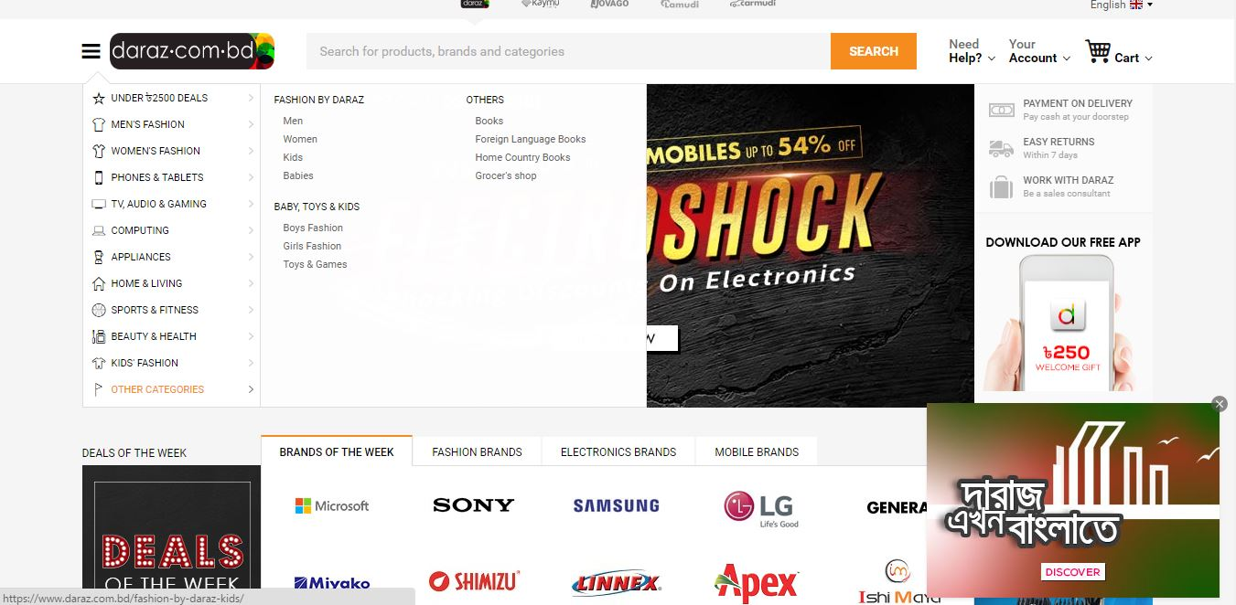
Illustration: Graphical Interface DARAZ Website

Except grocery and perishable goods customer can buy everything from Daraz. The enlistment of sellers are very easy. Any merchant who sells different product has physical shop or not can be a part of this visual giant marketplace but registering as a seller. Daraz has a proper seller management back end system Known as Seller Center. Where a seller or merchant can manage their visual store, enlist product, boost up any SKU for promotion, push his/her shop banner as well. Daraz maintain a proper content guild line. To upload any product on the platform merchant needs to handover product sample for photo-shoot with an additional charge.

Price
Price is another component of Market mix. Price that Daraz ask on website is decided and managed by the vendor or merchant with the help of their key account manager (KAM). Daraz is a platform which earns revenue from sales commission. Before enlisting seller, merchant/vendor Daraz make an agreement with them regard commission is going to be charged. The commission are charged based on category and merchants profits margin. Each order and successful delivery to the enduser count as a sales and Daraz logistics team collect the money and deduct their commission form the collected amount. So Daraz is basically a intermediate between seller and end user.

Promotion
All the ventures of Rocket Internet are promotion focused. So typically Daraz is also a venture whose core focus is on online promotion. Their Marketing team does different types of SEO and use different social media platform such as facebook, youtube, tweeter and others. They spend a huge portion of budget on online marketing. Apart from that they did different type of Celebrity Endorsement like- signing Mushfikur Rahim as brand ambassador. Campaign based program like Fatafati Friday with Robi. To reach its target group it has put its presence to all most all possible online sectors.
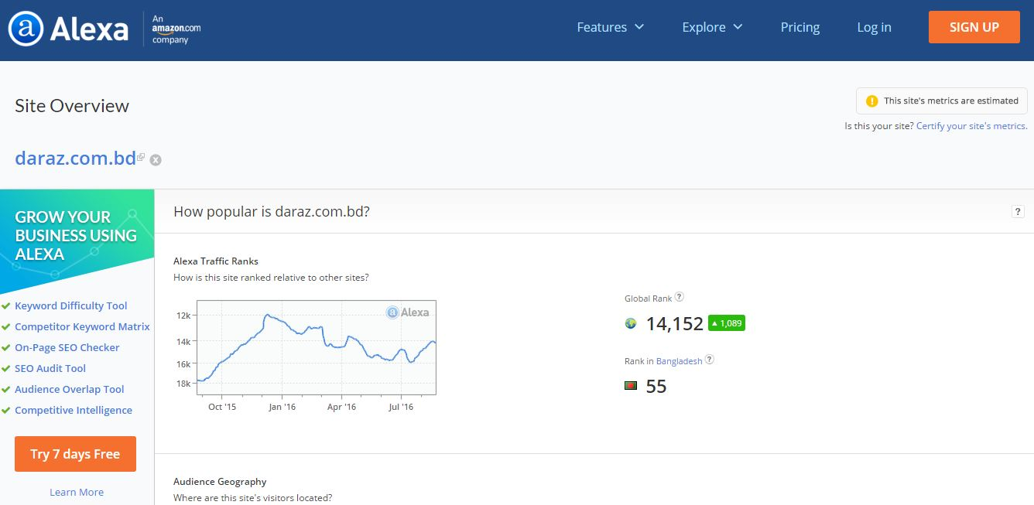
Illustration 1: online rank of www.daraz.com.bd (globally and locally)

Daraz has maintained its presence on Facebook, due to the heavy use of Facebook (Social Network) locally. Daraz sponsors ads on Facebook daily that reach outs 10 million Facebook users every day.

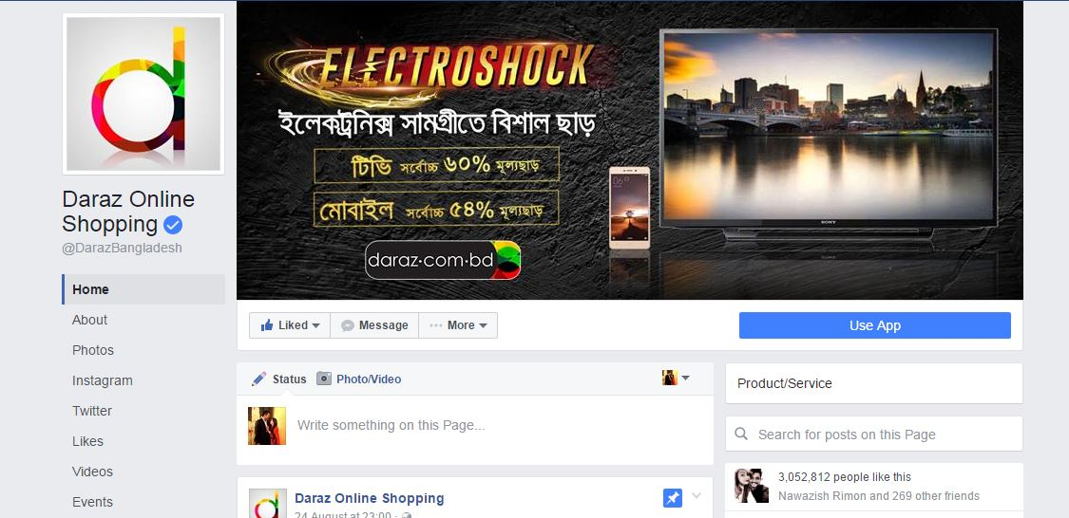
More than 3 million likes

Illustration 2: Facebook Page of Daraz Bangladesh Limited

Other than Facebook Daraz also making its mark on Twitter, and on Instagram as well. They are also using personal email database to reach 1 million (approx.) customers. Daraz is using the tele network as well, by sending sms promotions to gain its potential sales possibilities.

As a new comer in the market Daraz has covered its promotional needs on online platforms. However Daraz is still no actively participating in Above-The-Line (ATL) or Below-The-Line (BTL) communication channels.

Place
Like any other global successful venture Daraz has two type placement in market. One is visual like in mobile app and online web site www.daraz.com.bd where customer mainly buy or place order. Another one is their logistics and delivery chain through that customers get product.

People
As a new startup Daraz started their business with 04 people only. Now they have a team with more than 180 people. Rocket Internet maintain a cross culture where all the employees work in an open floor. Their employees from different countries and different backgrounds come under a roof top and build a better culture.
Vendor Management: Total personnel 26 (Hunter +incubator + Key Account Manager)

- Senior Vendor Manager: 3
- Vendor Manager: 23
  - Key Account Manager – 8
  - Longtail Account Manager – 15

- D- Force (Field Force): Total 45 Personnel
  - Head of Field Force: 1
  - Supervisor for Field Force: 3
  - Field Force Operative: 40

- Accounts and Finance : 08
- Head of Finance-01
- Billing Manager-01
- Collection Executive -04
- Payment Disbursement Executive -02
- Marketing Team – Total 8 Personnel

  - Marketing reporting – 2 Member
  - Social Media Integration – 3 Member
  - Partnership Development – 1 Member
  - Offline Promotion Support – 1 Member
  - Fashion Identity Project – 1 Head of the department
- Content Co-ordinatio – 2 Personnel
- Content Team – 20 Personnel
- Photography Setup – 5 Setups
- Operation
  - Head of Operations
  - Operation Manager (Outbound)-
      - In-house
        - Hub Manager-04
        - Outbound Executives-09
      - Third Party Logistics (3PL) Executives-02
      - Fleet Manager-01
        - Pickup Rider- 15
        - Delivery Rider-29
- Operation Manager (Inbound)-
- Warehouse Manager-02
  - Warehouse Executive-03
  - Operators & Picker-06
- Market Place Executives-08
Daraz offer competitive packages based on market. The recruitment has a unique process in Rocket Internet’s ventures. They hire freshman or little experienced with a dynamic characteristics. After recruitment the employees goes under rigorous on the job training for next 6 months after joining. By completing the successful period they become permanent employee of the company with an increment.

Physical Evidence
As a part of the component of marketing mix Daraz is always focus about the brands they are working with all the big brand and small brands has online banner in Daraz website. Every merchant’s physical shop there is an x-banner of Daraz with different promotional offers.
Few popular brands and highest sales volume merchants of Daraz-

- Bata
- Yellow
- Apex
- Samsung
- Huwai
- Myako
- Shimizu
- Sony
- Dorjibari
- Beauty Bazar
- Pearl
- Timezone
- RB
- P&G
- Microsoft (Lumia)
- LG
- Offprice
- Noir
- Walton
- O2
- Occult
- Sports World
- Body Shape

Daraz was the first online platform of Bangladesh who introduce proper packaging for e-commerce consumer in Bangladesh. Each of their delivery bikes, bi-cycles and vans carry the footprints in the market as their evidence in the market.

Process
Daraz is a complete online marketplace with proper process. They maintain different software for different purposes.
- Seller Center- It a module through which the merchant gets registered. Enlist their product on website, change price, assort products and manage their online store. On the other hand the vendor manager maintain the sales, update the data, and analyze different types of function and situation.
- CRM- For maintaining good relationship with customer Daraz customer care team use some modules like Zendesk, LMS, Zoho these types of software to maintain a healthy relationship and push sell.
- WOMS- Warehouse and Order Management system mainly used by the operations team and partially customer service team as well. It module help to keep inventory, manage orders, manage warehouse (both single & Multiple), return management, cross dock and drop ship.
- Delivery Module- This module helps the operation team to track vehicles, orders and parcels, manage inbound and 3pl delivery partners. This module is used by finance team as well to track down the daily delivery and collection reports.
Apart from those Daraz use different IT system like google BI software, SEO tools and others for marketing and data analysis.

Functional Overview

Overall Operation Process of Daraz

Illustration 3: The Operational process of Daraz

Daraz Operational Organogram

Daraz Bangladesh Limited started its journey in Bangladesh around September 2014 and launched in November 2014. For emerging markets, Daraz has certainly become the leading online marketplace. In a short span of time Daraz has grew exponentially. Daraz has a huge number of sellers already on board and also thousands are on their way to become Daraz sellers. Daraz operates as the one stop solution for customers to find their desired products online. Daraz has different departments to run its operations in Bangladesh.

CEO
Head of HR
Head of Operations
Head of D-force
Head of Fashion
Head of GM
CFO

Sr. Manager Customer Service

Agents
Operations Manager (Inbound)
Operations Manager(Outbound & 3PL)

Marketplace Manager
Warehouse Manager
Hub Manager
3PL Manager
Fleet Manager

Executives
Executives
Executives
Executives

Illustration 4: The Organogram of Daraz
Delivery Man
Fleet Supervisor
Pickup Personnel

Sales Strategy

Total Sellers for Acquisition Target: 650
Total assortment Growth Target: 40,000
Total Sales NMV (Net Merchandizing Value): 50,000 EURO
Out of Stock: Below 10%
Lead time for products going Live: 5 Days

Job as Operations Manager (Outbound & 3PL)

Description of the job
Operation Manager of an E-commerce platform required work in a dispatch center with warehouse and delivery system. As a founding member of Daraz I had to work in different teams. But most interesting thing about my job was to set up a logistics team for Daraz. I had to report to Finance Head as inventory and cash collection was under the supervision of Finance team at the same time I had to parallel reporting supervisor Head of Operations. I started working there from August 2014 up to May 2016. In this tenor I have learn so much things and mostly in hand experiences.

Key responsibilities of Operations Manager
- Logistics fleet spread across Multiple locations in Dhaka, Comilla, Chittagong
- Warehouse operations - Inbound, Inventory , Outbound, Third Party
- Marketplace vertical
- Returns and Quarantine management
- Optimization in Pick up and cut off times for Third Party Logistics Vendors
- Analyzing and optimizing routing for destination locations with help of Third Party Logistics Vendors
- Load balancing through Capacity Analysis of Third Party Vendors
- Manage 16 members’ teams of Delivery Queue Executive and Logistic fleet of 35 Deliveryman.
- Improved in process of Delivery Queue and Service Request performance
- Involvement in Dive and save escalations and Root cause analysis

Challenges and Experience from my Job

Setting up a logistics team is not a new thing but setting a team especially for e-commerce was very much challenging. The whole concept was new in our country just because we were about to introduce cross doc and drop ship model. These two model was totally unknown to the vendors. At the same time I had to my third party logistics team ready and make the understand the objective and business prospects. The whole eco system for e-commerce was not so ready to support the expansion business. But the business somehow expanded for so much effort, right team selection, make decision in the right time.

Recommendations that can develop Daraz operations

During my job in Daraz.com.bd I have seen so many obstacle closely. I have been a part of the process and I gave my best to develop so many things few of them are already implemented and more need to be implemented. So these are my recommendation
- Daraz should invest on their 3PL partners so that they can carry out their business smoothly.
- The training and personnel develop programs need to be more focused so that they key people of the company can develop themselves.
- Global practice in the company is very good but all the rocket people should maintain relation with other local companies as the whole sector is new so the mutual benefits is as important as competitions.
- As a startup resource selection is very important most of the startup do their biggest mistakes here. Daraz need not be more specific on their selection process.

Project& Events with Daraz

Summary
Being a part of this global economy Daraz Bangladesh has adopted the global e—commerce culture with in a very short time Daraz established as remarkable online platform in Bangladesh. Daraz has most dynamic sales team in Bangladesh who able to onboard almost every brands of general merchandising products and 70% of fashion brands of the country. To become market leader and expand the brand value Daraz has executed some big events-
- Mega Mobile Week -2015
- RobiFatafati Friday-2015
- Bangali New Year Campaign – 2016

These were the campaign I have done with Daraz during my working period. Those campaign was new for the e-commerce sectors in Bangladesh and bring a new experience for the customer in shopping online.

Description, Success & Limitations of the Events

Mega Mobile Week -2015
This was Daraz Bangladesh first event in Bangladesh where 17 mobile brands had participated. The duration of the event was one week and Daraz got orders more than Five thousand mobile phones and accessories from around the country. Among those order 82% were verified and confirmed and 62% were shipped and delivered. The return rate was 7% for different reasons. The most soled mobile handset was Honorholi by Huwauei. Other remarkable brands and models Samsung A-5, Nokia Lumia, Modes, 6 Degree.

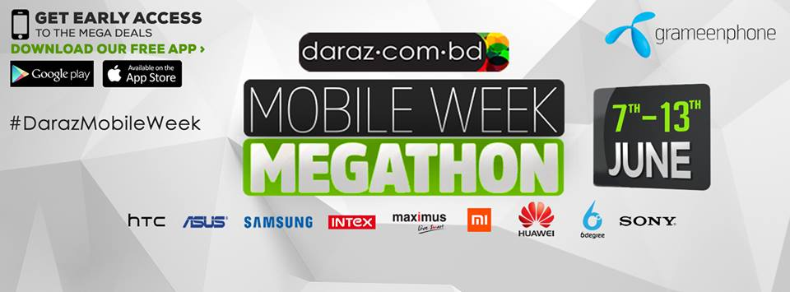
Illustration 5: Mobile week ofDaraz

Success of Mega Mobile Week –
Daraz Bangladesh made first footprint as a biggest online platform in the industries. The Sales was as high that was equal to the revenue of previous quarter. More brand become interested to work with Daraz Bangladesh. The Branded vendor acquisition was become easier. The platform start getting big corporate deals and Daraz introduce a whole new B2B sales team. The dependency on grey market reduces as some sole distributors of mobile phone hand set FDL, Mobile XL, and Edison Group showed interest to work with Daraz.

Limitations
As the event was big there were some limitations for that the events cannot reach the expectations. First of all the vendor was not so much clear about the projected sales volume and the operations model. As we introduce the drop ship model the vendor manager was not clear about the functions. During the event when we go so many orders most the orders was canceled because the enlisted vendors were out of stocked the demand was not fulfilled timely. Which created customer dissatisfaction. Secondly from the logistics side the whole team was not capable enough to pull the whole distribution and fulfillment. Inside Dhaka we were quite successful but outside Dhaka the dependency on 3PL was high and the 3PL failed to meet the demand. The product did not reached timely to the customer end, limitation of 3pl’s operation coverage was big issues of limitations.

RobiFatafati Friday
RobiFatafati Friday was another event by Daraz Bangladesh and it was the biggest event of Bangladesh E-commerce history. The event was hosted by Daraz and partnered by telecom company Robi. The objective was to introduce Black Friday Culture in Bangladesh. This Black Friday culture is mainly online and offline retail shops give super discount to their customer in the last Friday of November of the year. This culture is very popular in USA, Canada and many European countries. The features of this gala event-
- Over 2,000,000 SKU
- 5000 products had more than 50% discount
- More than 70 million taka discounts
- 72 established brand was onboard with discounts
- More than 20000 mobile phone were warehoused

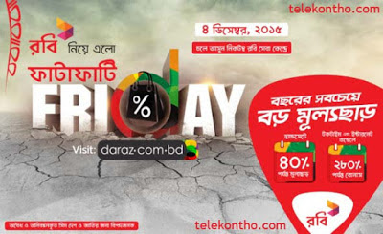
Illustration 6: Fatafati Friday by Daraz

Success
The event was three days long in these three day Daraz got more than 50000 orders. Among those orders 30000 orders was confirmed. Around 24000 orders had been delivered to the customers.

Limitations

It was the biggest event for Daraz but was not successful though the event achieves the break-even. The main limitation was the proper projections where Daraz was expected only 10000 order but got five time more and both the sourcing and infrastructure was not ready for the sales boost. Selection of partner was not good enough e.g. the concept of e-commerce business model not clear for the Robiteam. Consistency of rollout plan was not strong enough to support the capacity. Lack of distribution channels and regional office to operate this office properly.

Bangali New Year Campaign 2016-
Day by day traditional companies are breaking the belief of being in their own domain. They are showing interest in new business and many of them are targeting online as a new channel like modern trades. This year Unilever Bangladesh lunched another campaign called Bangali New Year Campaign. Plan was to experience the sales volume of their products. The target was to sales 2000 SKUs online.

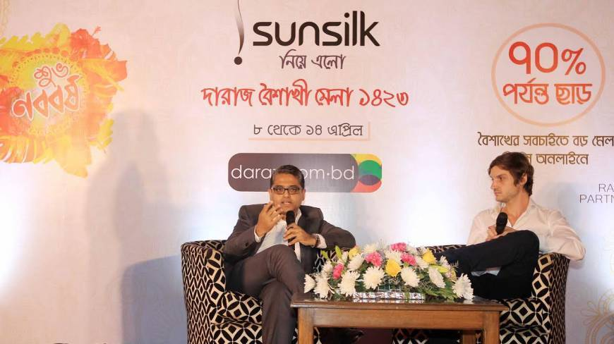
Illustration 7: Bangali New Year byDaraz
Success-
This one week long TR-02 campaign was achieved its target total generated order 6000 and confirmed order 4500 and 4200 were delivered.
Limitations –
After Fatafati Friday the team was quite prepared and everything was timly delivered. But Unilever was not able to sell 2000 SKUs their total sales was 200 SKUs.

Recommendation
I have observe the business of Daraz Bangladesh and this I would like to give some recommendation. Just like other Rocket Ventures most of the marketing and operational strategies from Germany but culture and other socio-economic components varies country to country. But they should start taking input local venture head and other mid-level managers.

As the business is expanding of Daraz they should have expand their operational offices in major cities e.g. regional cities of Bangladesh.
As E-commerce sector is expanding day by day in Bangladesh. Currently we have a market of 400 cores annually. Here are some recommendations-
- To emphasize on more online Daraz Bangladesh should start online payment process.
- They should do some real market survey on e-commerce and customer demand.
- Daraz should invest more on logistics and infrastructure development.
- Daraz should be more interactive with other market stakeholders.
- They should make their B2B channel.
- Daraz invest so much investment on online platform but in Bangladesh as it’s a developing country they should also in offline.
- Daraz should invest on their stakeholders development programs.

I hope if Daraz focus on those issues they can develop and gain much more market share

Conclusion
From my experience I can say Daraz Bangladesh is one of the most dynamic e-commerce platform and they are growing very rapidly. There they share knowledge and train their employees in a finest way. Working in their operations team I have gained so many things in a short time. I have developed my planning and forecasting skills and leadership skills. I would like to say like other company they are struggling a lot not because of their policies but also the whole sector in this county is growing and in this growing every sector faces ups and downs. But my best wishes will always for Daraz Bangladesh.

Appendix
- Order Fulfillment – Order fulfillment means the net verified order pick from the inventory, quality check, pack, labeled and call the customer regarding delivery lead time
- GMV – Gross Merchandising Value mean the charge that online retail show multiplying the number of merchandising with the amount paid by the customer.
- NMV – Net Merchandising Value means the value online retailers get after deducting all the fees and expenses from GMV
- Gross Order & Net Order – The total number of orders placed by the customer before verification known as Gross Order. After calling customer to verify his/her willingness to buy the products and confirming the product availability of the product from merchant end known as Net Order.
- Cross Dock – Picking the product from different merchants as per customer’s orders and consolidate all the product in same package/bucket for delivery known as Cross Dock.
- Drop-ship – Means when vendor fulfill the orders of the customer by their self and send it of delivery by own or third party logistics fleet.

REFERENCES
- https://www.daraz.com.bd
- http://www.alexa.com
- https://www.facebook.com/DarazBangladesh
- www.quora.com

