

September 11, 2014

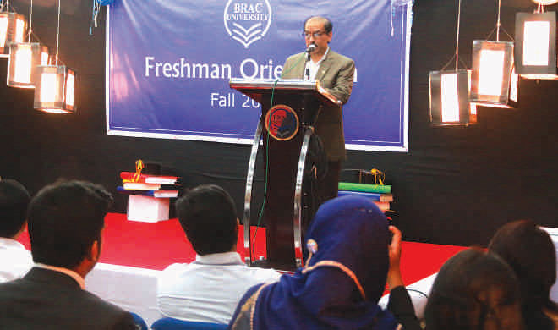
Freshman Orientation Program at BRAC University
The Undergraduate Orientation Program of Fall 2014 took place on September 8 at BRAC University's Mohakhali campus. Vice Chancellor, Professor Syed Saad Andaleeb, was the chief guest at the event. Professor Fuad Hassan Mallick, Pro-Vice Chancellor; Professor Riaz Partha Khan, Dean of Student Affairs Office & Teaching Learning Centre; Professor Firdous Azim, Chairperson of English & Humanities and Lady Syeda Sarwat Abed, Director, BRAC Institute of Language spoke on the occasion. Sukhendra Kumar Sarkar, Treasurer and Registrar; Muhammad Sahool Afzal were present along with the company of all heads of the departments, faculty members and administrative staff to welcome new undergraduate students with their parents who attended the session.
There was an interactive dialogue session between the concerned personnel and the guardians for better understanding of BRAC University campus life and co-curricular activities.

