

Sir Fazle Hasan Abed awarded the 2018 Lego Prize
Tribune Desk
Published at 01:18 AM April 12, 2018
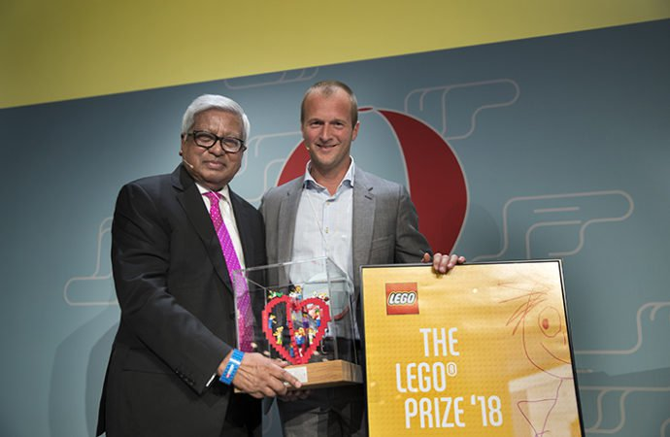
Sir Fazle Hasan Abed receiving the LEGO prize Courtesy

The prize included $100,000 to facilitate BRAC’s contribution to children living with neuro-developmental disabilities and their families
Sir Fazle Hasan Abed, founder and chairperson of BRAC, has been awarded the prestigious 2018 LEGO Prize for his unparalleled contribution towards improving children’s lives and their opportunities to play, learn and develop.
Thomas Kirk Kristiansen, deputy chairman of the board of Lego Foundation handed over the prize to Sir Abed at an event on April 10 in Denmark.
The LEGO Foundation, a Danish corporate foundation, has been awarding this prize since 1985 to individuals and organizations that are committed to the lives of children and are champions of learning through play.
The prize was accompanied by USD 100,000 to facilitate BRAC’s contribution to children living with neuro-developmental disabilities and their families.
BRAC has set up more than 1,400 play-based early childhood development centres across Bangladesh, Tanzania and Uganda, where close to 40,000 children aged one to five years are presently enrolled.
In addition to its early childhood development centres, BRAC operates around 10,000 pre-primary schools, 3,200 non-formal primary schools, 8,700 primary schools, and a university. BRAC also provides technical support to 3,846 primary schools.
Sir Fazle Hasan said: “It is an honour to receive the esteemed LEGO Prize. Every child deserves the opportunity to grow and develop. This generous financial contribution will support the holistic development of an under-deserved group of children in Bangladesh with special needs.”
“At BRAC, we pride ourselves on taking an innovative approach to early childhood development and education and share the LEGO Foundation’s passion for learning through play. Through our Play Lab program, we have experienced the power it can have in a child’s development,” he added.
Finnish educator and scholar Pasi Sahlberg, educationist, President of Reggio Children Carla Rinaldi, and Founder of Right To Play International are among previous winners of the LEGO Prize.

