

Education sector goes under huge reformation: Nahid
UNB NEWS
Wednesday 13 December, 2017 05:38:36 pm
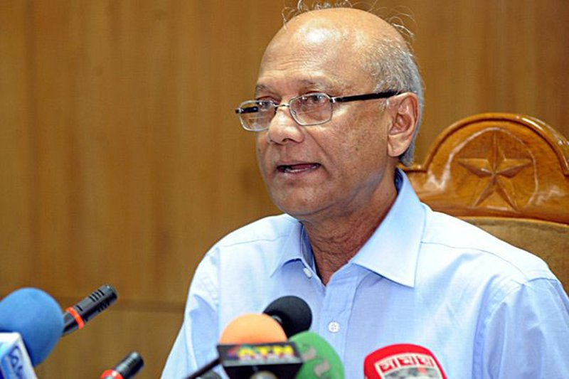

Savar, Dec 13 (UNB) – Education Minister Nurul Islam Nahid on Wednesday said that there has been a huge reformation in the education sector of the country during the rule of present government under the leadership of Prime minister Sheikh Hasina.
Attending the 12th convocation programme of BRAC University as representative of the President Abdul Hamid in Khagan area of Biralia union the minister came up with the remarks.
Nahid said, “People have to come forward with a view to contribute for welfare and sacrifice rather than making profit or business in education sector.”
Incumbent government has permitted for several new government and private universities to meet the demand of higher education and has taken necessary steps to sustain its qualitative standard, he said.
University Grant Commission chairman Prof Abdul Mannan, chairperson of BRAC University board of trustee Sir Fazle Hasan Abed, University’s Vice Chancellor Syed Saad Andaleeb were also present there.

